Test on Digital Images

Exam04 Digital Images

Activity 1 – Understanding images exersize
There are several file types used to store images. Most of these file types compress the image; The more often you edit and save, the more degraded the image will be.
Photographs are best saved as JPEG images. To gain a fuller understanding of manipulating images try the following:
- Select a digital photograph and try saving the image at different levels of compression. Your aim is to get the best balance between file size and image quality. Compare the file sizes and qualities of each saved image and then answer the following questions.
- At what point in compression does the JPEG become too poor to use on a web page? Is that point the same for all the photos you experimented with?
- How do the GIF and JPEG files compare in quality and file size? What conclusions can you draw?
- Create a graph comparing the JPEG file sizes against the different compression levels. Describe the trends. What conclusions can you draw?
- Create a table comparing and contrasting the following graphic file formats: BMP, GIF, JPEG and PNG. In your table include information on uses, colour, compression, size, lossy, advantages and disadvantages.
Use the internet and reference books to find all the information. The following web sites have some useful information on images.
  - www.wotsit.org .
  - http://graphicsoft.about.com
You need to include some graphics in an electronic presentation on the World Wide Web. The software program you are using only allows the graphic file formats: JPEG, GIF and PNG. The following two graphics of the same resolution are very different. Suggest the most appropriate format to use for each graphic, photo, rabbit and penguin and provide reasons for your choice.

Graphic 1 is Full colour photograph | Graphic 2 is a black and white line diagram
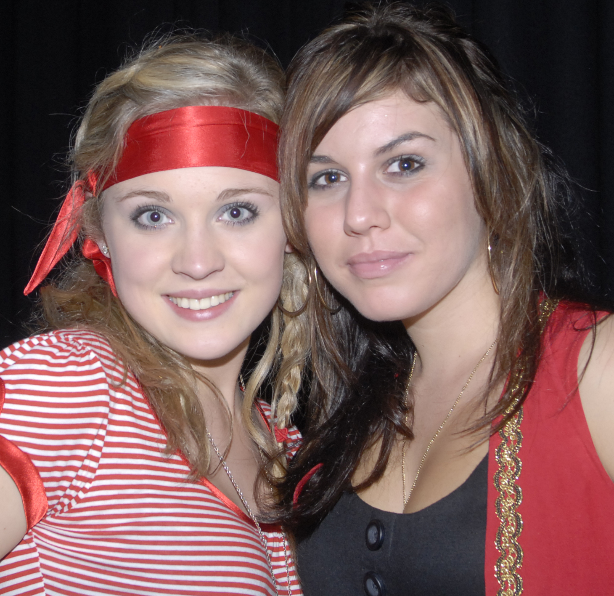 | 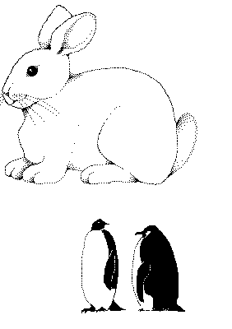

- Graphic 1
  - Format
  - Reasons
- Graphic 2 Rabbit
  - Format
  - Reasons
- Graphic 3 Penguin
  - Format
  - Reasons
You might like to discuss your answers with your teacher or compare results with fellow students.

Colour Depth Examples
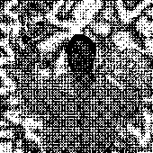 | 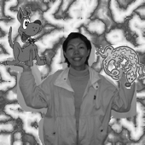
Black and White (1 bit) = 5 kb | Greyscale = 30 kb
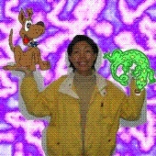 | 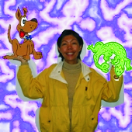
RGB Colour 8 bit = 46 kb | CMYK 32 bit = 79 kb

Activity 1 answer lossy question
File Format | BMP  Bitmap | GIF  Graphics Interchange Format | JPEG  Joint Photographic Experts Group | PNG  Portable Network Graphics
Uses | Pattern of pixels or tiny coloured dots. | Web graphics. Ideal for graphics that use only a few colours. Used for bitmap images – line drawings or blocks of a few distinct colours. | Web graphics. Photographs & scanned photos. Images with few distinct colours – illustrations, cartoons, icons & images with blocks of colour. | Web graphics. Single images only.
Colour | Fixed colour palette. | Maximum 256 colour. | True colour 24 bit graphics. Capable of displaying 16.7million colours. | True colour palette and grey scale. 16 million colours.
Compression | Not supported. | Highly compressed – no loss of data. | Smaller than GIF, less compression but better image quality. | 10 – 20% more than a GIF. No loss of data.
Size | Very large. |  | Highest quality – largest file.  Smaller files – reduced quality.
Lossy | Ans yes/no | Ans yes/no | Ans yes/no | Ans yes/no
Advantage | Good for small picture graphics & basic logos. | Can be transparent. Maintains resolution and sharpness even when compresses. Supports animation. | Compresses colour better and retains a high degree of colour fidelity. Can look almost as good as a photo. | Will eventually replace GIF. Platform independent. Greater colour support and better compression. Better support for transparency.
Disadvantage | Large file size. | Loses quality with high resolution pictures. Not effective for detailed photographs. | Not good with straight lines. Smaller file size the more picture info is lost & further away from original. Does not support transparency. | Doesn’t support animation. New format, so only recent browsers can display PNG graphics.

Save the work

